**TRAFFIC MANAGEMENT SYSTEMS (TMS)**

**Introduction**

Introduction Traffic Management Systems (TMS) use a variety of technologies to manage traffic flows and the effects of congestion on the roading network. Traffic Management Systems do this by addressing the traffic management effects of accidents and slow moving or queuing vehicles, planned events and extreme weather. TMS include, ramp signaling, dynamic lane management, variable speed limits, incident detection, vehicle activated signs and adaptive traffic signal control. Many of the systems are usually integrated to gain maximum benefit. Managing the allocation of road space is an important concept that is becoming increasingly relevant as it is not feasible or cost-effective to continue to accommodate the growth of urban traffic by constructing additional roads. It is widely acknowledged that a large part of added road capacity is often quickly absorbed by ‘induced’ demand.Traffic management refers to the systematic and organized control and regulation of road and transportation networks to ensure the safe, efficient, and orderly movement of vehicles, pedestrians, and goods. It encompasses a wide range of strategies, technologies, and practices aimed at minimizing traffic congestion, improving road safety, and optimizing the utilization of transportation infrastructure. The goal of traffic management is to enhance the quality of life for communities by reducing traffic-related problems and promoting the seamless flow of people and goods.

Key components of traffic management include:

1. **Traffic Control:** This involves the use of various traffic signals, signs, and markings to guide and regulate the movement of vehicles and pedestrians at intersections, crosswalks, and along roadways. It also includes the deployment of law enforcement officers to manage traffic during special events or emergencies.
2. **Traffic Signal Timing:** Adjusting traffic signal timings to accommodate the changing traffic patterns during different times of the day can help reduce congestion and improve traffic flow.
3. **Traffic Enforcement:** Law enforcement agencies play a crucial role in enforcing traffic laws and regulations to ensure that drivers and pedestrians follow the rules, which contributes to road safety and order.
4. **Public Transportation:** Encouraging the use of public transportation, such as buses and trains, can reduce the number of private vehicles on the road, alleviate congestion, and decrease environmental impacts.
5. **Transportation Planning:** Effective traffic management requires long-term planning and investment in transportation infrastructure, including the construction and maintenance of roads, bridges, and public transit systems.
6. **Traffic Information and Technology:** Utilizing modern technology, such as traffic cameras, sensors, and smartphone apps, can provide real-time traffic information to drivers, enabling them to make informed decisions about their routes.
7. **Traffic Calming:** Implementing measures like speed bumps, roundabouts, and narrower streets in residential areas can slow down traffic and enhance safety.
8. **Congestion Pricing:** Some cities employ congestion pricing strategies, where drivers are charged a fee to enter certain areas during peak hours, encouraging the use of public transportation and carpooling.
9. **Environmental Considerations:** Traffic management can also include efforts to reduce pollution and emissions by promoting cleaner and more sustainable transportation options.
10. **Emergency Management:** Traffic management plans are crucial during emergencies like natural disasters, accidents, or major events to ensure the safe and efficient movement of people and resources.

Effective traffic management requires a combination of policy development, infrastructure investment, public education, and technological innovation. It is a dynamic and evolving field, as urbanization, population growth, and changing transportation technologies continue to shape the way we move in our communities. Overall, the goal of traffic management is to create a safer, more efficient, and more sustainable transportation system that benefits both individuals and society as a whole.

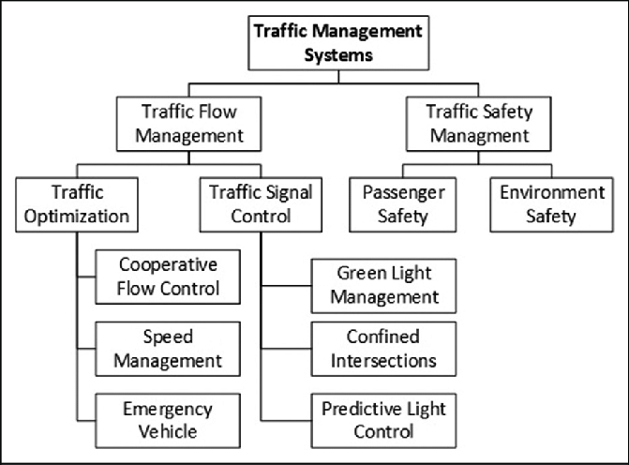

FLOW CHART :

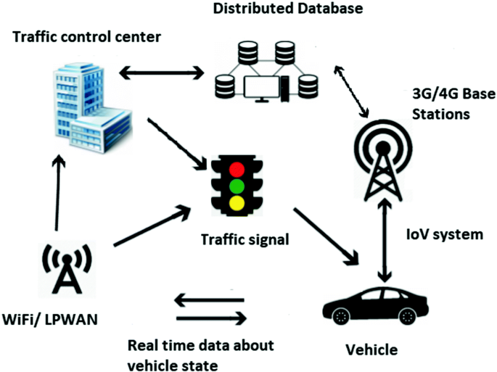

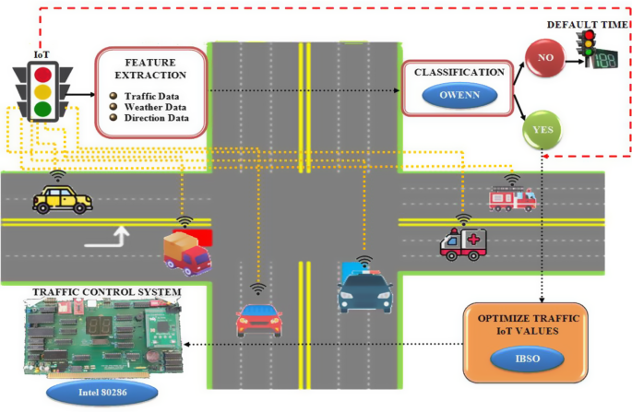

Circuit Diagram :

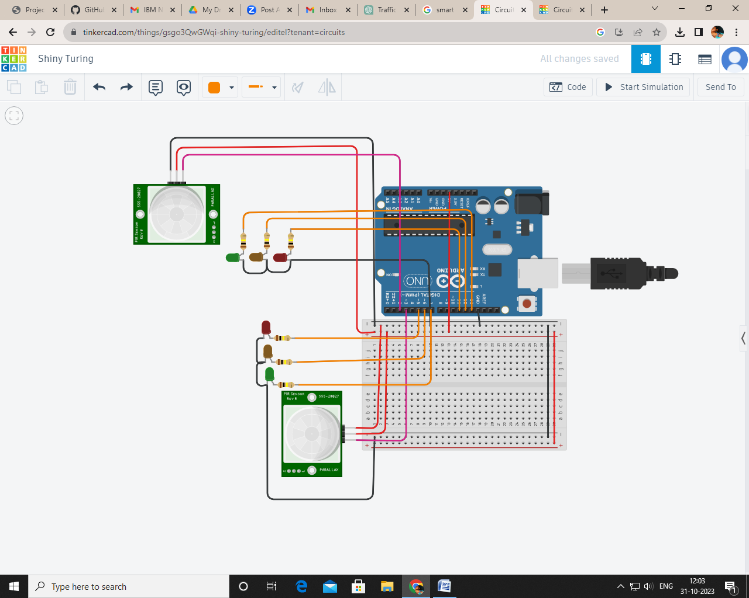

Link: https://www.tinkercad.com/things/gsgo3QwGWqi-shiny-turing/editel?tenant=circuits

Program :

// Pin sensor Pir

int sh = 2;

int sv = 3;

// Valores de los sensores

int valh = 0;

int valv = 0;

// Pin semaforo vertical

int rv = 5;

int av = 6;

int vv = 7;

// Pin semaforo horizontal

int rh = 11;

int ah = 12;

int vh = 13;

void setup()

{

for (int i = 5; i <= 13; i++) {

pinMode(i, OUTPUT);

}

pinMode(sh, INPUT);

pinMode(sv, INPUT);

Serial.begin(9600);

}

void loop()

{

valh = digitalRead(sh);

valv = digitalRead(sv);

Serial.print("Horizontal: ");

Serial.println(valh);

Serial.print("Vertical: ");

Serial.println(valv);

Serial.println();

int th1 = 3000;

int th2 = 400;

int tv1 = 3000;

int tv2 = 400;

if (valh == HIGH && valv == LOW) {

Serial.println("Aumentar Horizontal");

th1 = th1 * 2;

th2 = th2 * 2;

} else if (valh == LOW && valv == HIGH) {

Serial.println("Aumentar Vertical");

tv1 = tv1 * 2;

tv2 = tv2 * 2;

}

semaforoHorizontal(th1, th2);

semaforoVertical(tv1, tv2);

}

void semaforoHorizontal(int t1, int t2) {

digitalWrite(rv, HIGH);

digitalWrite(vh, HIGH);

delay(t1);

digitalWrite(vh, LOW);

digitalWrite(ah, HIGH);

delay(t2);

digitalWrite(rv, LOW);

digitalWrite(ah, LOW);

}

void semaforoVertical(int t1, int t2) {

digitalWrite(rh, HIGH);

digitalWrite(vv, HIGH);

delay(t1);

digitalWrite(vv, LOW);

digitalWrite(av, HIGH);

delay(t2);

digitalWrite(rh, LOW);

digitalWrite(av, LOW);

}

Circuit Diagram :

Program :

int temt6000Pin = A0;// Analog pin for reading sensor data

int temt6000Pin2 = A1;// Analog pin for reading sensor data

int temt6000Pin3 = A2;// Analog pin for reading sensor data

int temt6000Pin4 = A3;// Analog pin for reading sensor data

float light;

float light2;

float light3;

float light4;

int light_value;

void setup() {

Serial.begin(112500);

pinMode(temt6000Pin, INPUT); //data pin for ambientlight sensor

pinMode(temt6000Pin2, INPUT);

pinMode(temt6000Pin3, INPUT);

pinMode(temt6000Pin4, INPUT);

pinMode(13, OUTPUT);

pinMode(12, OUTPUT);

pinMode(11, OUTPUT);

pinMode(10, OUTPUT);

}

void loop() {

int light_value = analogRead(temt6000Pin);

int light_value2 = analogRead(temt6000Pin2);

int light_value3 = analogRead(temt6000Pin3);

int light_value4 = analogRead(temt6000Pin4);

light = light_value * 0.0976;// percentage calculation

light2 = light_value2 * 0.0976;

light3 = light_value3 * 0.0976;

light4 = light_value4 * 0.0976;

Serial.println(light);

Serial.println(light4);

delay(100);

if (light_value > 30) {

digitalWrite(13, HIGH);

}

else {digitalWrite(13,LOW);}

if (light_value2 > 30) {

digitalWrite(12, HIGH);

}

else {digitalWrite(12,LOW);}

if (light_value3 > 30) {

digitalWrite(11, HIGH);

}

else {digitalWrite(11,LOW);}

if (light_value4 > 30) {

digitalWrite(10, HIGH);

}

else {digitalWrite(10,LOW);}

}